

Chairperson’s Pitch
The highwayman

Your newsletter of Central Yorkshire District Association of the Camping and Caravanning Club

Publisher; Dave Pickersgill Volume Number; 1 Issue Number; 2 Date; Winter 2007
The highwayman

Your newsletter of Central Yorkshire District Association of the Camping and Caravanning Club

Publisher; Dave Hawksworth Volume Number; 4 Issue Number; 1 Date; Spring 2012

Hello everyone.
Welcome to a new camping season, let’s hope this weather is a sign of a good summer.
Sad news to start with, with the passing of Geoff Proctor. There was a great turnout from his camping friends at his funeral. He was a valued member of CYDA and his humour will certainly be missed on our meets.
I would like to apologise for the problems we had with the website in the last few months but would like to thank Dave Hawksworth and Paul Bellwood for all their hard work in restoring it back to normal. It wasn’t easy and took a great deal of time and effort.
I have been in touch with Yorkshire Air Ambulance and the total we raised last year was £2039.45. A great total and a very big thank you to anyone who helped in raising this large amount.
Our AGM is on Saturday 31st March and anyone wanting to join the committee should contact an existing committee member. It would be nice to have some new faces along with some different ideas and views, so don’t be shy.
The Easter Meet follows, where we have all the usual Easter activities, including the world famous duck race. It gets bigger year on year and I’ve heard that there are ducks flying in from all corners of the globe to take part. The follow–on meet is back and we are at River Laver (Parkfield), Ripon which opens at 4pm as Pateley Bridge closes. April meets continue at Cononley, Skipton and Lockside, Ripon and I hope to see you at any or all of our meets.
We are looking for prizes for our tombola stall at Easter, so, if you have anything, please pass them on to Mandy or myself.
Also, we are making a list of people that are wanting to join the working party for the Yorkshire Region Meet at Carlton Towers in June 2012, which is being organized by CYDA. If you are interested, please let me know.

Thank You

Bob Hannam

Chairman

Bowling Night

We had a D.A. bowling night on Saturday 4th February at Shipley Bowl. It was very popular with 38 people booking including 6 children but, due to the sudden snowfall on Saturday teatime, 16 people could not get to Shipley due to the blocked and snowy roads. However, the people that did get there thoroughly enjoyed the night out. We had two games of bowling, a basket meal and a free drink all for £12 (£7 for children). The bowling alley looked after us very well and it wasn’t a problem having to cancel 16 meals having pre-booked them.

The highest adult score was Bob 265
The highest child score was Emily 214

We plan to do this again next year, so don’t delay and get your names down so you don’t miss out.

Bob Hannam

A Note Of Appreciation

This year, 2012, marks 50 years membership of our Club for Anne and myselfbut more important to us is 50 years with Central Yorkshire D.A. During that time we have made so many friends and enjoyed their company whilst camping.
At the End-Of-Season annual dinner dance, our Chairman Bob and ‘First Lady’ Mandy, together with many other friends made a surprise presentation to us to mark this Special Occasion, for which Anne and I are humbly grateful.. We are the first in the D.A. to achieve this honour and, to the best of my knowledge, it will be several more years before it happens again.
So once more, Many, Many Thanks to all our D.A. friends and we hope to be with you all for some time to come.

Best Wishes to all from
Anne and Raymond Davison

ITS TOO DIFFICULT, ARE WE TOO OLD, OR LETS JUST DO IT

From your CYDA correspondent in Spain.
Well it’s our third year wintering in the sun (most of the time). It is certainly to be recommended.
We set off in August 2011 for a THS near Oxford very nice flat field with some electric available, near Chipping Norton. Very handy for Oxford and the dreaming spires and of course Inspector Morse/now Lewis.Blenheim Palace well worth a visit (birthplace of Sir Winston Churchill).
In September we set sail for France via Portsmouth/Caen a six-hour smooth crossing en route to La Garangeoure a camping club rally on the Vendee. We can both recommend this rally well run and plenty to do, even a real circus to close the site on the last day. Like all rallies you either love em or hate em. We loved it your decision.
Having had 21 days on the rally we moved down to the Pyrenees Mountains for a rest, it was really good and the mountain air was fantastic, I might add that so far we have had three days rain.
After 5 days we moved through the Somfort tunnel 28 kms long into Spain. Then duel carriageway all the way to Barcelona.5hrs and we were on the campsite 30kms south of Barcelona called Villanova il la Getru.it felt like coming home our third time and to meet up with old friends of all nationalities was terrific back to the old German and schoolboy French, even a little Russian this time, a truly international site. For £8.20 a day with electric and facilities that put the club sites to shame, we stayed for three months. We flew home at mass from Barcelona airport to Manchester (unfortunately luggage in Gatwick) but they sorted it and it was delivered by taxi Xmas eve. A great time and a children and grandchildren fix for Pauline. Having eaten for England and partaken of a little alcohol we flew back after six days for another rest.
I may add that we celebrated remembrance Sunday and New Years Eve, as you would expect both with the reverence you would expect. You try and eat a grape every chime of the New Year. It’s not easy!
We moved down to Bennicassim 70 kms north of Valencia on the 3rd January ready to celebrate the Spanish festival of the Three Kings, which is really the Spanish Xmas.
We have just had one of the biggest street parties we have ever been to all cooking family paellas in the street over open fires there must have been two hundred individual party places all the streets cordoned off and all the side streets full no trouble no drunkenness just good family fun. We walked up the shops this morning the place is spotless everything cleared away not a sign of a massive festival. We are looking forward to future events, Burns night, the Harley Davison festival’s Patrick’s Day, Valentine’s Day and many more.
We sail back to UK 3rd April and look forward to seeing you all at Pateley Bridge, and the looming Region Meet.

Asta la vista

Dave and Pauline Pickersgill

Dave & Pauline Pickersgill with friends in Spain

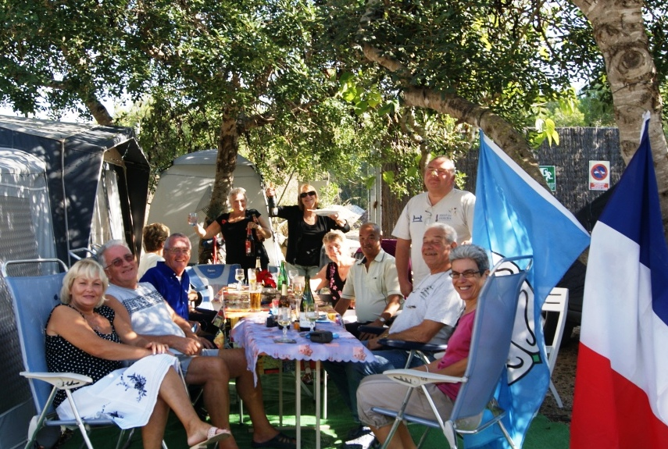

I did not know this………

When you drink vodka over ice, it can give you kidney failure.
When you drink rum over ice, it can give you liver failure.
When you drink whiskey over ice, it can give you heart problems.
When you drink gin over ice, it can give you brain problems.
Apparently, ice is really bad for you, so warn all your friends!

PRICELESS!

A father asked his 10 year old son if he knew about the birds and the bees.
“I don’t want to know,” the child said, bursting into tears.
“Promise you won’t tell me.”
Confused, the father asked what was wrong.
The boy sobbed, “When I was six, I got the ‘There’s no Easter Bunny’ speech.
At seven, I got the ‘There’s no Tooth Fairy’ speech.
When I was eight, you hit me with the ‘There’s no Santa’ speech.
So if you’re going to tell me that grown-ups don’t really ‘do it’,
I’ll have nothing left to live for.”

I’M PLANNING A HOLIDAY

I’m planning a holiday sometime this year,
Somewhere relaxing and not very dear.
I’ve been reading the adverts for ages and ages,
Yesterday’s paper had 24 pages.
I’ve been to the agents and looked through the brochures,
And some of the prices were really atrocious.
‘Wish You Were Here’ shows such exotic places,
It’s never Dad paddling in flat cap and braces.

Some hotels abroad have menus that spoil it,
Like choosing live lobster then watching them boil it.
India’s out ‘cause I never eat curry,
I don’t like to fly and I’m sick on the ferry.
Timeshare sharks pester you in the Canaries,
Madeira sounds fine but the temperature varies.
Benidorm’s spoilt with the lager louts’ racket,
And the Costa Del Sol can cost you a packet.

I’ve thought about Rome and watching the fountains,
Austria’s nice but there’s too many fountains.
I could rent a caravan up in the Dales,
Or how about hitch-hiking all around Wales?
There’s an advert for Bradford but that sounds a bore,
Blackpool’s OK but I’ve been there before.
Scotland’s too cold and Greece is too sunny,
Barbados too far and it costs too much money.

I could learn to ski or try parascending,
There’s a murder weekend. Oh! The list’s never ending.
There’s a five-star hotel where you live like a Lord,
What should I book? B&B or half-board?
I was never much good at making decisions,
I can’t sort out the prices with all those additions.
The sea view is extra and so is the shower,
It seems there is nothing that makes the price lower.

I know what I want but it’s so hard to find,
I just want a change from the old daily grind.
Somewhere to go without travelling far,
Where I can watch the telly and don’t need a car.
Somewhere in solitude, somewhere to think,
Somewhere away from the kitchen sink.
I’m wanting a place that’s not over-rated,
And any exchange rates are soon calculated.

I’ve thought of a place I won’t need travellers’ cheques,
And won’t be disturbed by the opposite sex.
I’ll not have to pay room supplement,
Right here in my garden, I’m pitching my tent! Provided by Anne Davison

4 WORMS IN CHURCH

A minister decided that a visual demonstration would add emphasis to his Sunday afternoon sermon.
Four worms were placed in 4 separate jars.
The first worm was put into a container of alcohol.
The second worm was put into a container of cigarette smoke.
The third worm was put into a container of chocolate syrup.
The fourth worm was put into a container of good clean soil.

At the conclusion of the sermon, the Minister reported the following results:
The first worm in alcohol…….Dead
The second worm in cigarette smoke…….Dead
The third worm in chocolate syrup…….Dead
The fourth worm in good clean soil……. Alive

So the Minister asked the congregation, ‘What did you learn from this demonstration?’
Maxine, who was sitting at the back, quickly raised her hand and said,

‘As long as you drink, smoke and each chocolate, you won’t get worms!’

THE TOILET SEAT

Charlie’s wife, Lucy, had been pestering him for several weeks to paint the seat on their toilet. Finally, he got round to doing it while Lucy was out. After finishing, he left to take care of another matter before she returned.

She came home and undressed to take a shower. Before getting into the shower, she sat on the toilet. As she tried to stand up, she realized that the not-quite-dry epoxy paint had glued her to the toilet seat.

About that time, Charlie got home and realized her predicament. They both pushed and pulled without any success whatsoever.

Finally, in desperation, Charlie undid the toilet seat bolts. Lucy wrapped a sheet around herself and Charlie drove her to the local hospital A&E department. The ER Doctor got her into a position where he could study how to free her.

Lucy tried to lighten the embarrassment of it all by saying, “Well, Doctor, I’ll bet you’ve never seen anything like this before”

The Doctor replied, “Actually, I’ve seen lots of them…….. I just never saw one mounted and framed.”

THE LOTTERY

A husband says to his wife, “What would you do if I won the Lottery?”

She says, “I’d take half then leave you”

“Excellent,” he replies, “I just won £10, so here’s £5 – now get lost!”
THE SHEER NIGHTGOWN

A husband walks into ‘Victoria’s secret’ to purchase a sheer negligee for his wife. He is shown several possibilities that range from £250 to £500 in price – the more sheer, the higher the price. Naturally he opts for the most sheer item, pays £500 and takes it home.
He presents it to his wife and asks her to go upstairs, put it on, and model it for him.

Upstairs the wife thinks (she’s no dummy), ‘I have an idea. It’s so sheer that it might as well be nothing. I won’t put it on but I’ll do the modeling naked and return it tomorrow and keep the £500 for myself.’ She appears naked on the balcony and strikes a pose.

The husband says, “Good grief! You’d think for £500, they’d at least iron it!”

He never heard the shot!

Funeral is on Thursday at Noon. Donations in lieu of flowers to the National Association for Retarded Husbands (NASH).

Then and Now… A technology error

As we Silver Surfers know, sometimes we have trouble with our computers.
I had a problem yesterday, so I called Eric, the 11 year old next door, whose bedroom looks like Mission Control , and asked him to come over.
Eric clicked a couple of buttons and solved the problem.
As he was walking away, I called after him, “So what was wrong.?”
He replied, “It was an ID ten T error.”
I didn’t want to appear stupid but nevertheless enquired. “An ID ten T error? What’s that in case I need to fix it again?”
Eric grinned…….”Haven’t you ever heard of an ID ten T error before?
“No.” I replied.
“Write it down,” he said, “I think you’ll figure it out.”
So I wrote it down: ID10T
I used to like Eric, the little ………………!

TRUE BLISS?

A married couple had been out shopping at the local retail complex for most of the afternoon, when suddenly, the wife noticed that her husband had disappeared.
The somewhat irate woman called her husband’s mobile phone and demanded, “Where the hell are you?”

Husband replies, “Well darling, you remember that Jewelry shop where you saw the diamond necklace and totally fell in love with it, but I didn’t have the money at that time and told you one day it would be yours.”

Wife with a smile and blushing: “Yes, I remember that my Love.”

Husband: “Well, I’m in the Pub next door to that shop.”

NEW…….. For Senior Travel



THE THREE BEARS

Baby bear goes downstairs, sits in his small chair at the table. He looks into his small bowl which is empty. “Who’s been eating my porridge?” he squeaks.

Papa arrives at the big table and sits in in his big chair. He looks into his big bowl which is also empty. “Who’s been eating my porridge?” he roars.

Mummy bear puts her head through the serving hatch from the kitchen and yells, “For God’s sake, how many times do I have to go through this with you idiots? It was Mummy bear who got up first. It was Mummy bear who woke everyone in the house. It was Mummy bear who made the coffee. It was Mummy bear who unloaded the dishwasher from last night and put everything away. It was Mummy bear who swept the kitchen. It was Mummy bear who went out in the cold early morning air to fetch the newspapers. It was Mummy bear who walked the dog, cleaned the cat litter tray, gave them their food and refilled their water dishes. It was Mummy bear who set the damn table.”

“And now that you’ve decided to drag your bear-bottoms downstairs and grace Mummy bear with your grumpy presence, listen carefully because I’m only going to say this once....”

I HAVEN’T MADE THE B***** PORRIDGE YET!



Forgetter Be Forgotten?

My forgetter’s getting better,
But my rememberer is broke
To you that may seem funny
But, to me, it’s not a joke

For when I’m ‘here’ I’m wondering
If I really should be ‘there’
And, when I try to think it through,
I haven’t got a prayer!

Oft times I walk into a room,
Say ‘what am I here for?’
I wrack my brain, but all in vain!
A zero is my score.

At times I put something away
Where it is safe, but, Gee!
The person it is safest from
Is, generally, me!

When shopping I may see someone,
Say ‘Hi’ and have a chat,
Then, when the person walks away
I ask myself, ‘who the hell was that?’

Yes, my forgetter’s getting better
While my rememberer is broke,
And it’s driving me plumb crazy
And that isn’t any joke.

CAN YOU RELATE?



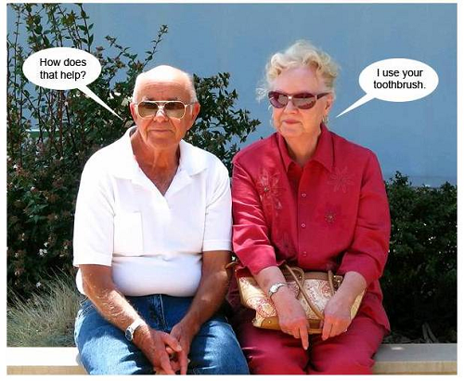

The Pitfalls of Opportunism!

A tough group of bikers were riding when they saw a girl about to jump off a bridge, so they all stop.
The leader, a big burly man, gets off his bike and says, “What are you doing?”
“I’m going to commit suicide” she says.
While he did not wish to appear insensitive, he didn’t want to miss an opportunity.
So he asks “Well, before you jump, why don’t you give me a kiss?”
So she does and it was a long, deep lingering kiss.
After she’s finished, the biker says “Wow! That was the best kiss I have ever had. That’s a real talent you are wasting, you could become famous. Why are you committing suicide?”

“Cause my parents don’t like me dressing up as a girl!”

SECRET TO A LONG AND HAPPY MARRIAGE

A couple was celebrating their golden wedding anniversary on the beaches of Montego bay, Jamaica. Their domestic tranquility had long been the talk of the town. People would say, “What a peaceful and loving couple.”
The local newspaper reporter was enquiring as to the secret of their long and happy marriage.
The Husband replied: ‘Well, it dates back to our honeymoon in America.’ explained the man.’
‘We visited the Grand Canyon, in Arizona, and took a trip down to the bottom of the canyon by horse. We hadn’t gone too far when my wife’s horse stumbled and she almost fell off. My wife looked down at the horse and quietly said, “That’s once”.’
‘We proceeded a little further and the horse stumbled again. Again my wife quietly said, “That’s twice”.’
‘We hadn’t gone half a mile when the horse stumbled for the third time. My wife quietly removed a revolver from her purse and shot the horse dead’
‘I SHOUTED at her, “What’s wrong with you, woman! Why did you shoot the poor animal? Are you crazy?”
She looked at ME, and quietly said ‘That’s once.’

‘And from that moment on…….we have lived happily ever after.’

A Wish for Grandpa


“Dear God. Please send clothes for all those poor ladies on Grandpa’s computer. Amen.”

Attendance call on the first day at school in Baildon, West Yorkshire.

The teacher begins calling out the names of the pupils:

“Mustafa El Ekh Zeri”

“Here”

“Achmed El Kabul”

“Here”

“Fatima Al Choudary”

“Here”

“Abdul Alu Ohimi”

“Here”

“Mohammed Ibn Achrha”

“Here”

“Mi Cha El Mey Er” Complete silence in the classroom

“Mi Cha El Mey Er” Continued silence as everyone looked around the room.

She repeated, “Is there any child here called Mi Cha El Mey Er?”

A boy arose and said, “Sorry teacher, I think that must be me. It’s pronounced Michael Meyer.”
SUNNY DAY REFRESHMENTS

MANGO & COCONUT SPLASH (serves 2)

1 ripe mango, 2 tbsp clear honey, 100ml (4 fl oz) Greek yoghurt, 200ml (7 fl oz) coconut milk, 1 lime, handful of ice cubes.

Peel the mango, cut away all the flesh from the stone and place in liquidizer. Add the honey with the yoghurt, coconut milk and lime juice. Tip in the ice cubes with 100ml (4 fl oz) of water and blend to a puree.
Pour the drink into tall glasses and serve.

For a variation, try replacing the mango with a chopped banana or some chopped pawpaw with twice the lime juice.

BAILEYS & BANANA DREAMBOAT (Serves 2)

50g (2oz) plain chocolate, 2 ripe miniature bananas, 100ml (4 fl oz) Baileys Irish Cream, 2 tbsp maple syrup, 100g (4oz) Greek yoghurt, 100ml (4 fl oz) milk, handful of ice cubes.

Break the chocolate into squares and melt it in a heatproof bowl set over a pan of simmering water for 3 minutes or on high in a microwave for 2 minutes. Leave to cool a little and then swirl around two tall glasses and set aside for 5 minutes to set.
Peel and slice the bananas and add to a liquidizer. Add the Baileys, maple syrup, yoghurt, milk and ice and blend until smooth. Pour the dreamboat into the chocolate-decorated glasses and serve.

JUNIOR CORNER

Spring Jokes

- What season is it when you are on a trampoline?
- Mary’s mother has 4 children, their names are Summer, Autumn, Winter and ????
- What do you call a girl with a frog on her head?

Easter Jokes

- Why did the Easter egg hide?
- What do you call a bunny with a large brain?
- What did the rabbit say to the carrot?

From Scott, Ryan & Kate

PUZZLE PAGES

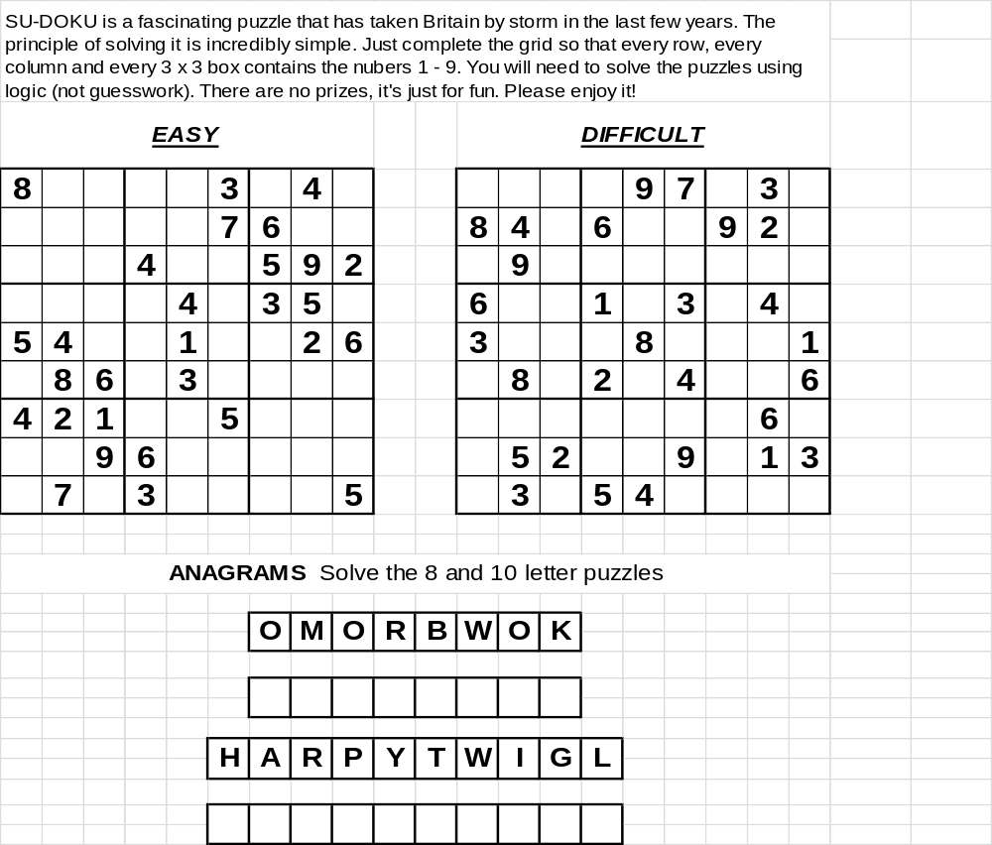

MISSING LINKS
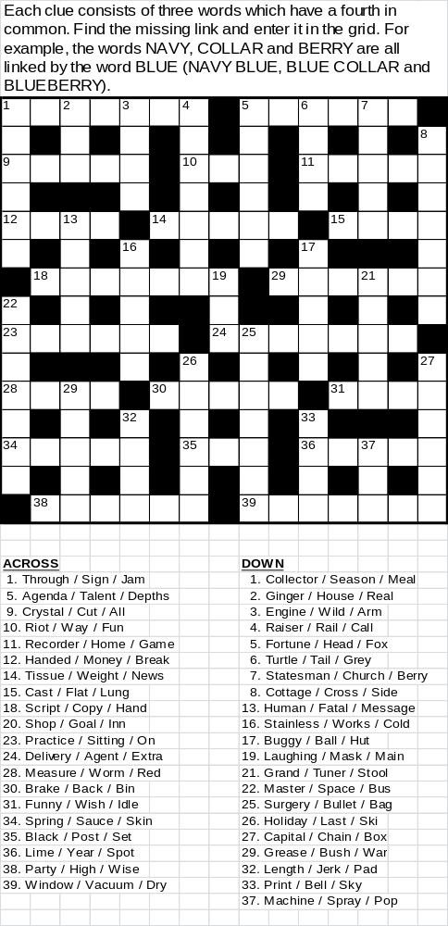
REGION MEET 2012 - Carlton Towers 21st to 25th June ‘THE BIG TOP’
BOOKED ENTERTAINMENT
MELODY LANE
A husband and wife duo with a unique style of vocal harmony, and multi instrumental talent. This duo has been highly regarded on the International Cabaret Scene. They have worked many Summer Seasons, travelled to the Falklands and the Ascension Islands entertaining the Armed Forces. They have recently been to the Canary Islands and the Gulf of Oman.
The couple have worked with celebrities like Shane Ritchie, Tom O’ Connor, Buck’s Fizz, and Ken Dodd. They also appeared in the BBC series of Bergerac. Their music ranges from 1960s to the present day and have been described as ‘Sheer Class’.
JAMIE ANSBRO
A superb all round personality male vocalist who sings songs from the 1950’s to the present day. Artists include Roy Orbison & Matt Monroe to Kings Of Leon & The Killers. He has a full album recorded with covers from Whitney Houston to The Wanted and Elton John to The Drifters.
The Award Winning HEROES
Heroes is a fully professional four piece band. The group do cover versions of the greatest songs ever. Together for over eight years the emphasis is always on entertainment giving the audience what they want. With decades of experience, a totally self-contained group with a logic professional sound system and a fully intelligent automated light show. They are the innovators of the ‘Rear Projection System’.
‘An absolutely tight knit performance throughout.’
They won Best Band Award 2012 for the Nottingham area.
Not to be missed! An experience in itself!
EVENTS & ATTRACTIONS
Trade stands, Raffle, Tombola, Sports, Mardi Gras led by Majorettes, Vintage Car Rally, It's A Knockout, Bar with inexpensive drinks plus many more attractions.
ADMIN TENT
Stalls include 'Name the Clown' competition, Raffle, Tombola, Book Purchase/Exchange, CD stall etc.
Top Raffle Prizes include;
a). 14 night camping break for up to 6 people on most UK Club Sites.
b). P & O Ferry return crossing between Dover & Calais for a car and caravan/trailer or motorhome for 6 people.
c). DFDS Ferry return crossing between Dover & Dunkirk for a car and caravan/trailer or motorhome for 4 people.
d). Red Funnel return crossing between Southampton & Cowes for a car and up to 7 passengers.
e). Camping and Caravanning Club manouvering course
f). Land Rover Experience half day course at any Land Rover Experience centre around the UK.

For further information and updates, log on to ‘www.cydaonline.co.uk’ or ‘www.yorkshireregion.co.uk’

A copy of the 2012 Sites List for CYDA can be found below or online at www.cydaonline.co.uk

Please do not hesitate to visit the website or to contact a committee member if you wish to enquire about the information contained in this leaflet.
 |  | C.Y.D.A. SITES LIST 2012
Start | Site |  |  |  |  |  |  | Stewards |  |  |  |  |  |  | Nights
23/03/12 | South Newlands - Riccall |  |  |  |  |  |  | Malcolm & Christine |  |  |  |  |  |  | 3
29/03/12 | Joinery Works – Great Ouseburn |  |  |  |  |  |  | Chris & Margaret |  |  |  |  | 4
05/04/12 | Pateley Bridge Showground |  |  |  |  |  |  | George & Miriam, Dave & Yvonne |  |  |  |  |  |  | 5
10/04/12 | Parkfield - Ripon |  |  |  |  |  | Dave & Yvonne |  |  |  |  |  |  |  | 5
19/04/12 | Riverside - Cononley |  |  |  |  |  |  | Bill & Jackie |  |  |  |  |  | 4
26/04/12 | Lockside - Ripon |  |  |  |  |  |  | Brian & Josie |  |  |  |  |  |  | 4
03/05/12 | Fountain House Farm - Clapham |  |  |  |  |  |  |  |  |  |  |  |  |  | 5
08/05/12 | Croft Farm – Bradley, Skipton |  |  |  |  |  |  | Peter & Gloria |  |  |  |  | 5
16/05/12 | Parkfield - Ripon |  |  |  |  |  |  | Goerge & Miriam |  |  |  |  |  | 4
18/05/12 | Driving Range - Yarm |  |  |  |  |  |  | Martin & Bob G |  |  |  |  |  |  | 5
24/05/12 | Mount Terrace - Pickering |  |  |  |  |  |  | Chris & Margaret, Bob & Carol |  |  |  |  |  | 18
14/06/12 | Holme House Farm - Gargrave |  |  |  |  |  |  | Peter & Gloria |  |  |  |  |  |  | 3
25/06/12 | Askham Lane Nurseries - Askham Bryan, York |  |  |  |  |  | George & Miriam |  |  |  |  |  | 13
12/07/12 | Cracken House Farm - Leyburn |  |  |  |  |  | Malcolm & Christine |  |  |  |  |  | 17
02/08/12 | Lockside - Ripon |  |  |  |  |  |  |  |  |  |  |  |  |  | 27
06/09/12 | Threaplands - Cracoe |  |  |  |  |  |  | Geraldine & Denise |  |  |  |  |  | 4
13/09/12 | Askham Lane Nurseries - Askham Bryan, York |  |  |  |  |  |  | George & Miriam |  |  |  |  |  |  | 5
21/09/12 | Rudding House Farm - Pannal |  |  |  |  |  |  | Dave & Graham |  |  |  |  |  |  | 2
28/09/12 | Eggborough Sports & Social Club |  |  |  |  |  |  | Ray & Margaret |  |  |  |  |  |  | 5
04/10/12 | Newsholme Manor - Oakworth |  |  |  |  |  |  | Cyril & Edna |  |  |  |  | 3
11/10/12 | Bank Top Farm – Newton In Rawcliffe |  |  |  |  |  |  | Shaun |  |  |  |  | 10
25/10/12 | Lightwater Valley - Ripon |  |  |  |  |  |  | Dave & Yvonne |  |  |  |  |  |  | 7

We always need stewards for weekend and THS’s, if you are interested in stewarding, please contact one of our committee.

CYDA Committee Details
Bob Hannam | Chairperson | 07786004396 bob.hannam1@btinternet.com
Dave Hawksworth | Vice Chairperson | 07719223312 dave1203@talktalk.net
Eunice Sutcliffe | Secretary | 01535655377 eunicerobin@hotmail.co.uk
Helen Hopper | Treasurer | helen.hopper@sky.com
Yvonne McMullen | Public Relations Officer | 01132770622 ymcmullen@hotmail.com
Margaret Vallance | Youth Leader | 01405831066 margaretvallance@hotmail.com
Ray Vallance | Sites Officer | 07965581181 ray.vallance@virginmedia.com
Bob Hannam | Rep To Region | 07786004396 bob.hannam1@btinternet.com.
Dave Hawksworth | Website Officer | 07719223312 dave1203@talktalk.net
Michelle Hill | Committee Member | 07930625396 michelle.hill72@tiscali.co.uk
Josie Lee | Committee Member | 01274617749 josielee@btinternet.com
Tony Sutcliffe | Committee Member | 07936389223 tonysutcliffe@blueyonder.co.uk

Important Dates for your Diary

29th Mar – 4 nights – AGM - Great Ouseburn
5th Apr – 5 nights – Easter Meet – Pateley Bridge
3rd May – 5 nights – May Day Weekend – Clapham
21st Jun – 4 nights – Yorkshire Region Meet – Carlton Towers
25th Jun – 13 nights – Strawberry Meet – Askham Bryan
13th Sep – 5 nights – CYDA FOL – Askham Bryan
4th Oct - 3 nights – Dinner Dance – Newsholme Manor, Oakworth
25th Oct - 7 nights – Halloween Meet - Lightwater Valley, Ripon
28th Dec - New Year Meet (to be advised)

Newsflash
Ow’t you want to say, tips to pass on? Fancy writing a report on a holiday just like the big boys? Do you have any camping equipment you wish to sell? Do you have a favourite recipe or simply an anecdote you wish to share. All contributions are always welcome (providing it’s printable). Get any info to me for the next issue of Highwayman as early as possible please. If you have t’internet my address is; dave1203@talktalk.net or simply contact me on 07719223312.

JUNIOR JOKES

Spring Answers

1). Springtime!
2). Mary!
3). Lily

Easter Answers

1). He was a little chicken!
2). Egghead!
3). It’s been nice gnawing you!

Puzzle page solutions
MISSING LINKS
ACROSS |  |  |  |  |  | DOWN
1. Traffic |  |  |  |  |  | 1.Ticket
5. Hidden |  |  |  |  |  | 2. Ale
9. Clear |  |  |  |  |  | 3. Fire
10. Run |  |  |  |  |  | 4. Curtain
11. Video |  |  |  |  |  | 5. Hunter
12. Even |  |  |  |  |  | 6. Dove
14. Paper |  |  |  |  |  | 7. Elder
15. Iron |  |  |  |  |  | 8. Country
18. Writing |  |  |  |  |  | 13. Error
20. Keeper |  |  |  |  |  | 16. Steel
23. Target |  |  |  |  |  | 17. Beach
24. Special |  |  |  |  |  | 19. Gas
28. Tape |  |  |  |  |  | 21. Piano
30. Pedal |  |  |  |  |  | 22. Station
31. Bone |  |  |  |  |  | 25. Plastic
34. Onion |  |  |  |  |  | 26. Resort
35. Out |  |  |  |  |  | 27. Letter
36. Light |  |  |  |  |  | 29. Paint
38. Street |  |  |  |  |  | 32. Knee
39. Cleaner |  |  |  |  |  | 33. Glue
 |  |  |  |  |  | 37. Gun

SUDOKU  EASY |  |  | DIFFICULT

8 | 6 | 5 | 2 | 9 | 3 | 1 | 4 | 7 |  |  | 2 | 6 | 5 | 4 | 9 | 7 | 1 | 3 | 8
2 | 9 | 4 | 1 | 5 | 7 | 6 | 3 | 8 |  |  | 8 | 4 | 3 | 6 | 1 | 5 | 9 | 2 | 7
1 | 3 | 7 | 4 | 6 | 8 | 5 | 9 | 2 |  |  | 1 | 9 | 7 | 3 | 2 | 8 | 6 | 5 | 4
7 | 1 | 2 | 8 | 4 | 6 | 3 | 5 | 9 |  |  | 6 | 7 | 9 | 1 | 5 | 3 | 8 | 4 | 2
5 | 4 | 3 | 7 | 1 | 9 | 8 | 2 | 6 |  |  | 3 | 2 | 4 | 9 | 8 | 6 | 5 | 7 | 1
9 | 8 | 6 | 5 | 3 | 2 | 4 | 7 | 1 |  |  | 5 | 8 | 1 | 2 | 7 | 4 | 3 | 9 | 6
4 | 2 | 1 | 9 | 8 | 5 | 7 | 6 | 3 |  |  | 9 | 1 | 8 | 7 | 3 | 2 | 4 | 6 | 5
3 | 5 | 9 | 6 | 7 | 1 | 2 | 8 | 4 |  |  | 4 | 5 | 2 | 8 | 6 | 9 | 7 | 1 | 3
6 | 7 | 8 | 3 | 2 | 4 | 9 | 1 | 5 |  |  | 7 | 3 | 6 | 5 | 4 | 1 | 2 | 8 | 9

ANAGRAMS
B | O | O | K | W | O | R | M

P | L | A | Y | W | R | I | G | H | T

